My Traffic Crash Analysis MiniProject – 1 Report
Jessica Sriramula

Brief summary of my project:
In this project I have been provided with the traffic crash dataset csv file which contains valuable and meaningful insights that can help improve road safety, optimize emergency response, and support policy decisions. To achieve these insights, I have utilised VScode and Mysql and writing the python and mysql code.
After downloading the traffic crash dataset csv file provided, moved it into mysql database, and then I made a mysql connection with VScode to import the csv file into VScode from mysql, then I used the pandas library in VScode to read the csv file, and I have written the python and mysql code in VScode to extract and filter the data that I want to see for each of the 15 queries, and presented the output of the python and mysql codes into tabular form for each of the 15 queries.

The 15 data output query results that I have extracted and filtered from the traffic crash dataset csv file in VScode are:
- Find the top 5 most dangerous combinations of weather and crash type based on total crashes.
- Identify the top 10 streets with the highest number of injury crashes.
- Find the percentage of crashes that resulted in injuries for each crash type.
- Determine the peak crash hour for each month.
- Find the top 5 primary causes of crashes during night time (CRASH_HOUR ≥ 18).
- Compare average number of injuries in daylight vs darkness conditions.
- Find which traffic control device type has the highest average injuries per crash.
- Identify the top 5 locations (latitude/longitude) with the highest crash frequency.
- Find the top 5 streets with the highest injury rate, considering only streets with more than 100 crashes.
- For each year, identify the most common crash type.
- Find the day of the week with the highest average crashes per hour.
- Identify high-risk time slots:
- Group hours into buckets (Morning, Afternoon, Evening, Night)
- Find which bucket has the highest injury crashes
- Find the top 3 contributing causes for each crash type.
  - (Using window functions like ROW_NUMBER() or RANK())
- Calculate the year-over-year growth rate of crashes.
  - (Using LAG() window function)
15. Identify hotspot zones:
- Group nearby locations (round latitude & longitude to 2 decimal places)
- Find top 10 zones with highest crashes

Streamlit:
After extracting and filtering the above 15 queries in VScode, I have displayed them in streamlit, here is a screenshot of my streamlit pages(Home, Queries).

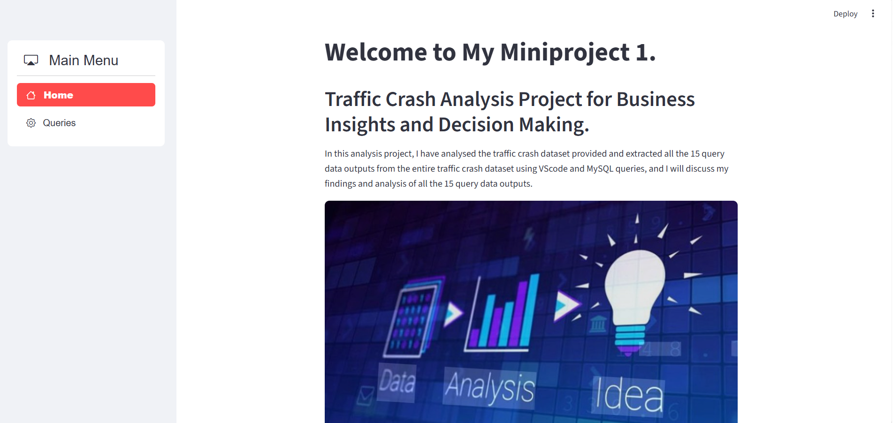
This is my streamlit project home page.
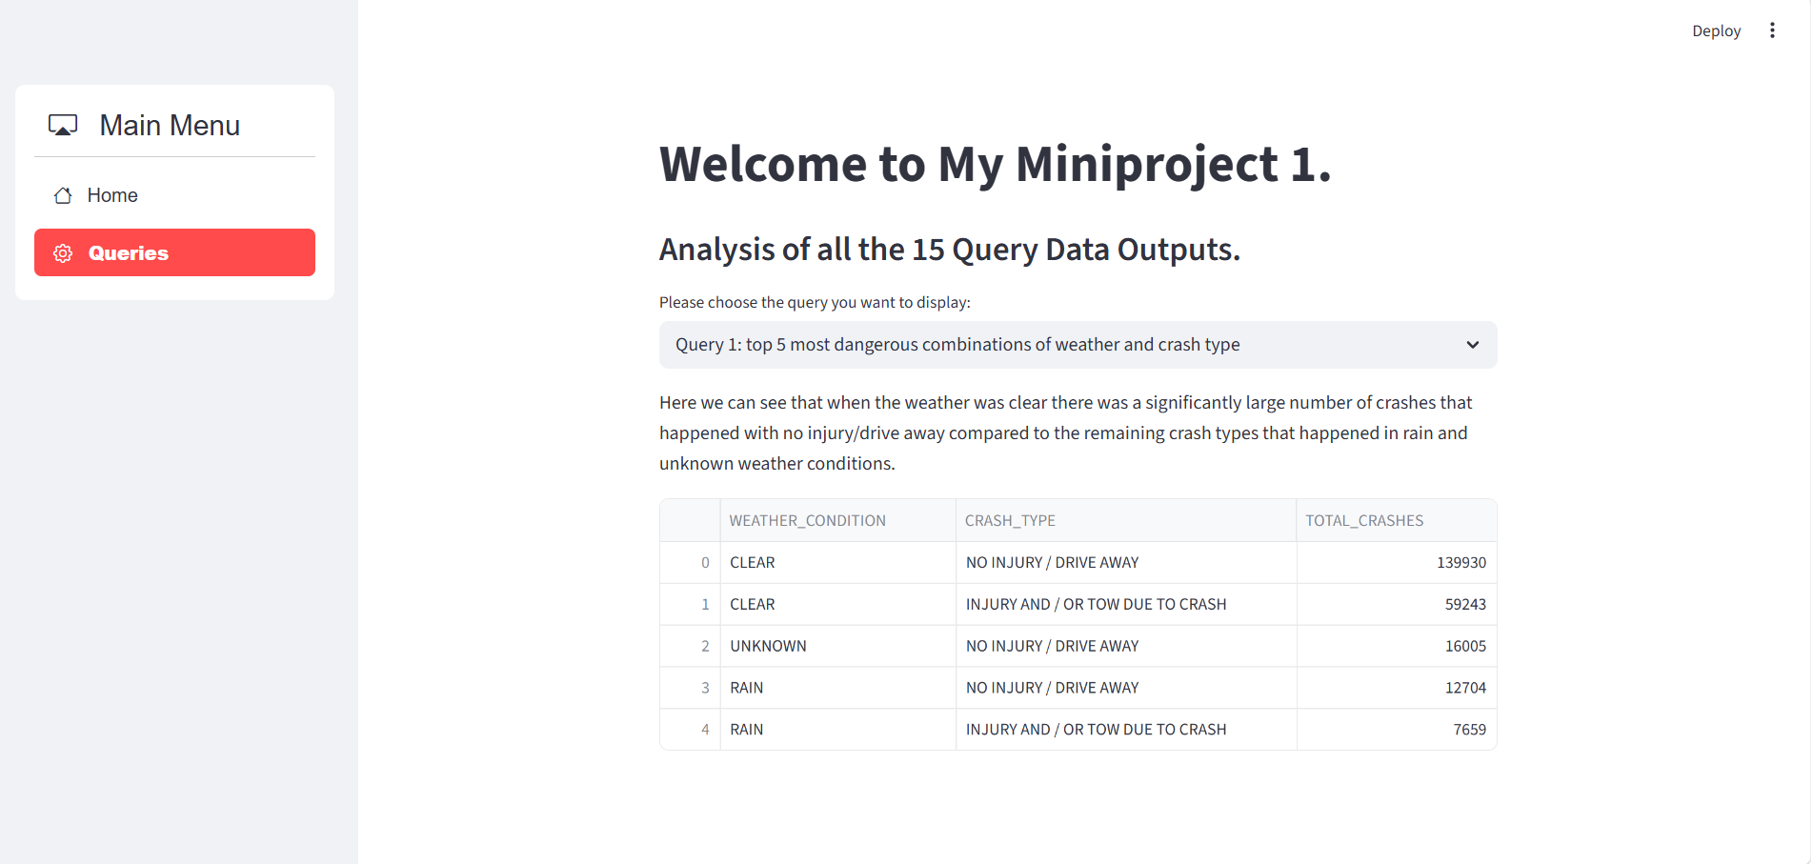
Drop-down menu.
This is my queries page in streamlit.
In this queries page of my streamlit, we can see all the above mentioned 15 data output query results in a table format using the drop-down menu.
Please Note: In my streamlit queries page we can see 18 queries instead of 15 queries this is because I have split some of the 15 queries into two separate queries for easier representation.

Outcomes of my project:
(business insights and decision making):
The outcomes from my project data analysis are:
- Can be used to help minimize the number of traffic crashes and injuries in high-risk zones, and times and in different weather conditions.

- Can be used to help implement road traffic safety measures to reduce the total number of crashes and injuries.

- Can be used to inform drivers what causes accidents, injuries and crashes so drivers can make better decisions for driving on the road.

- Can be used to alert traffic police officers about an injury or crash that took place and how to deal with future incidents promptly based on the past traffic crashes and injuries data trends.

- Can be used to make better decisions for road traffic officers on the road attending to the crashes/injuries site and the drivers who will drive on the road such as not driving in risky weather conditions if it can lead to a crash/injury or keeping road traffic officers on the road informed about the best way to respond to a crash/injury.

- Therefore in conclusion, my project analysis can be used to identify high-risk streets and accident-prone zones for traffic authorities, analyze factors contributing to high-severity crashes for insurance companies, evaluate response effectiveness using time-based data for emergency services, understand impact of road types and conditions for urban planning, study crash trends and contributing causes for research and policy making.

